PHASE 5: Project Development Phase
Project Team Members
M.G Misriyathul Ibrahima
S.M.B.N Meera Jenira
V.Mohana
P.Mutharasi
S.A.K. Muthu Ameena

Project: Implement Client Script & UI Policy (Incident)
ServiceNow – Incident Management

Phase Objective
To implement the planned ServiceNow configuration in the Incident module.

UI Policy Implementation
The High Impact Control UI Policy was created for the Incident table with Impact = 1 – High as the condition and Reverse if false enabled.

UI Policy Action Implementation
The UI Policy Action was configured for the Incident field shown in the project evidence, with Mandatory behavior applied to Assigned To. The Urgency field was also designed to become read-only under the High Impact condition.

onChange Client Script
The script checks whether the changed Impact value is 1. If so, it sets the Urgency field to 1 and displays an informational message: “Urgency set to High for High impact incident.”

onSubmit Client Script
The script checks whether Impact is 1 and Assigned To is empty. If both are true, it shows an error on Assigned To and returns false to prevent submission.

onCellEdit Client Script
The script displays an alert stating that State cannot be updated using list editing and calls callback(false) to reject the list edit.

Implementation Result
The uploaded recording shows the UI Policy configuration and the resulting Incident form behavior, including automatic Urgency handling and Incident field validation.

Project Evidence – Screenshots
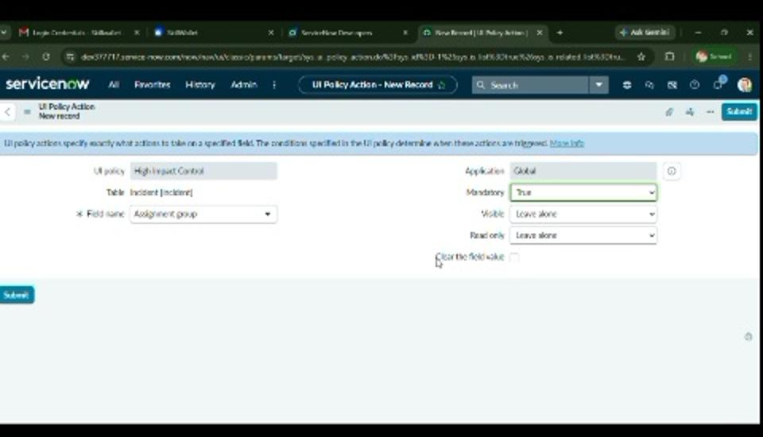
Figure 7. UI Policy Action configuration.
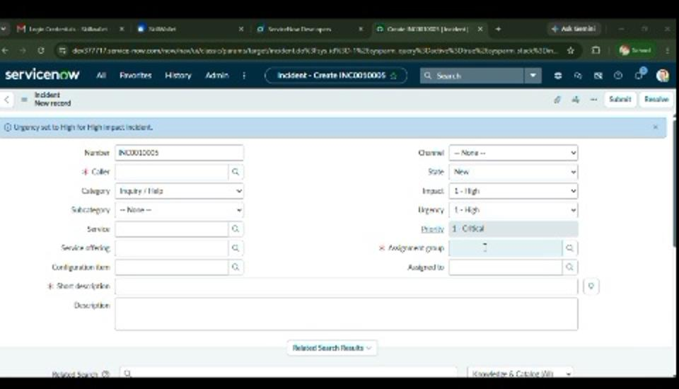
Figure 8. Incident form with Impact = High and Urgency automatically set to High.
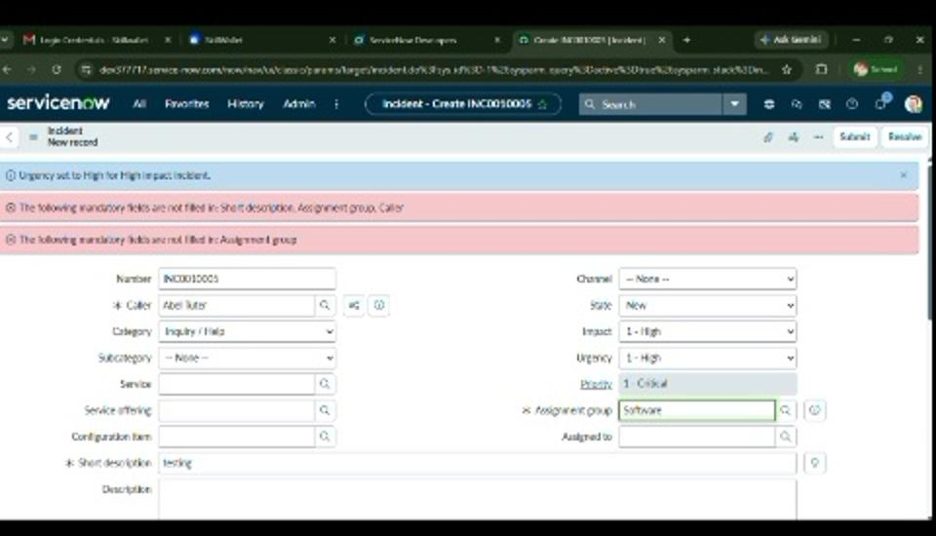
Figure 9. Incident form showing validation messages during the configured workflow.
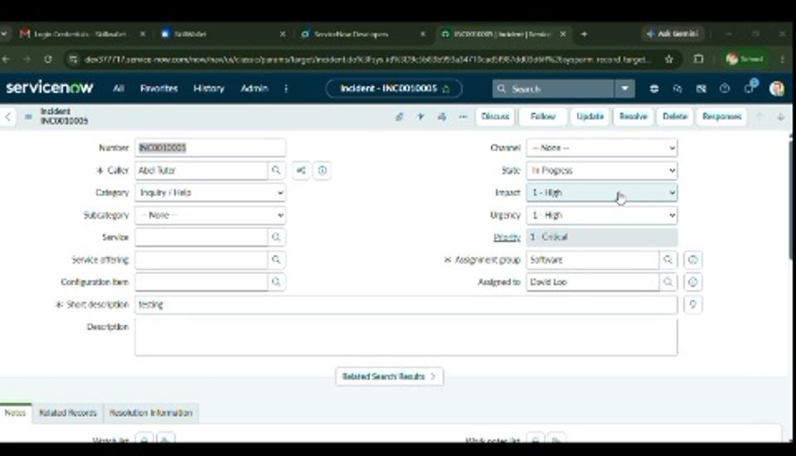
Figure 10. Incident record after required information is provided.

Phase Outcome
The planned ServiceNow configuration was implemented and the uploaded evidence shows the UI Policy, UI Policy Action, and Incident behavior.

